Exam Report

Submitted by: Justine Biju
Batch: S4 CSE
Roll Number: 37
Set: 5

Question 1
Write a shell script to generate all 3 digit numbers that contain only the
digits 0, 1, 2, 3 (number doesn’t start with 0)

Solution:
Three nested loops are used, to permute the numbers which can only be formed by 0, 1, 2, 3.
The outermost loop iterates between [1, 2, 3] while the rest iterates between [0, 1, 2, 3].
The values of the three loops are concatenated to form the required three digit numbers.

<code---------------------------------------------

for i in 1 2 3;do
for j in 0 1 2 3;do
for k in 0 1 2 3;do
echo "$i$j$k"
done
done
done

----------------------------------------------end>
Output:
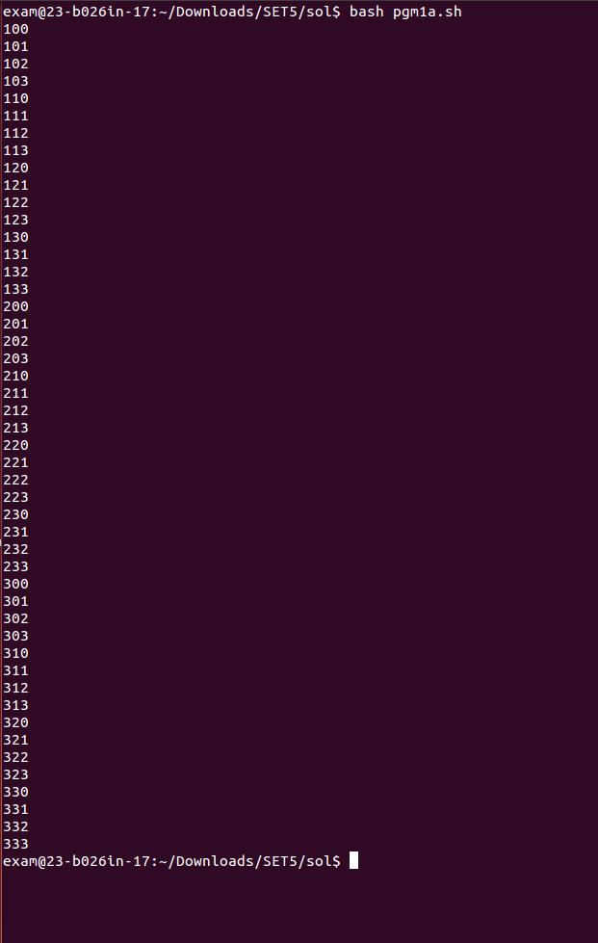

Question 2
Write a program that analyzes Apache logs. Display the number of bytes served by each path. Ignore unsuccessful page requests. If there are more than ten paths, display the first ten only. Following is a sample line from an Apache access log.

92.50.103.52 - - [19/Aug/2018:08:26:43 -0400] "GET
/perl/automated-testing/next_active.gif HTTP/1.1" 200 980
"​ http://example.com/perl/automated-testing/navigation_bar.htm​ " "Mozilla/5.0 (X11; U;
Linux x86_64; en-US; rv:1.8.1.6) Gecko/20061201 Firefox/3.0.0.6 (Fedora); Blazer/4.0"
The two numbers following the HTTP/1.1 are the response code and the byte count. A response code of 200 means the request was successful. A byte count of - means no data was transferred.

(Test case Available in Folder ‘2’)

Solution:
The required fields are selected using the 'awk' command and is put to a temp file 't.temp'
A while loop is used iterate the temp file. And corresponding values are stored.
An if statement is used to check whether the error code is 200 and the count of paths from that domain is less than 10.
The path and the bytes transferred is echoed.

<code---------------------------------------------

awk -F " " '{print $1 " " $7 " " $9 " " $10}' $1 | sort -k1 >> t.temp
pre=""
count=0
while read line;do
domain=`echo $line | awk -F " " '{print $1}'`
path=`echo $line | awk -F " " '{print $2}'`
scode=`echo $line | awk -F " " '{print $3}'`
bcount=`echo $line | awk -F " " '{print $4}'`
if [[ $scode == "\"-\"" ]];then
scode=" "
fi
if [[ "200" -eq "$scode" && count -lt 10 ]];then
echo "Domain: " "$domain" "Path: " "$path" "Bytes served: " $bcount $count
fi
if [[ $pre == $domain ]];then
((count++))
else
pre=""
count=0
fi
pre=$domain
done < t.temp
rm -f t.temp

----------------------------------------------end>

Output:
- On access.log
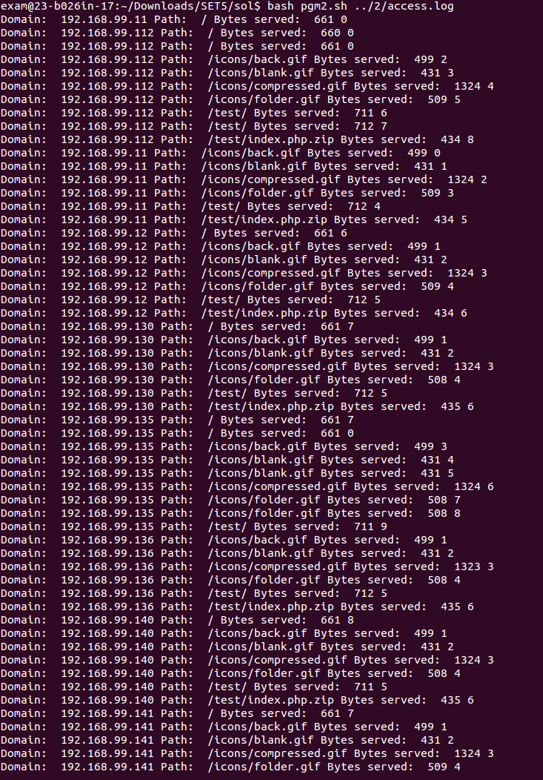
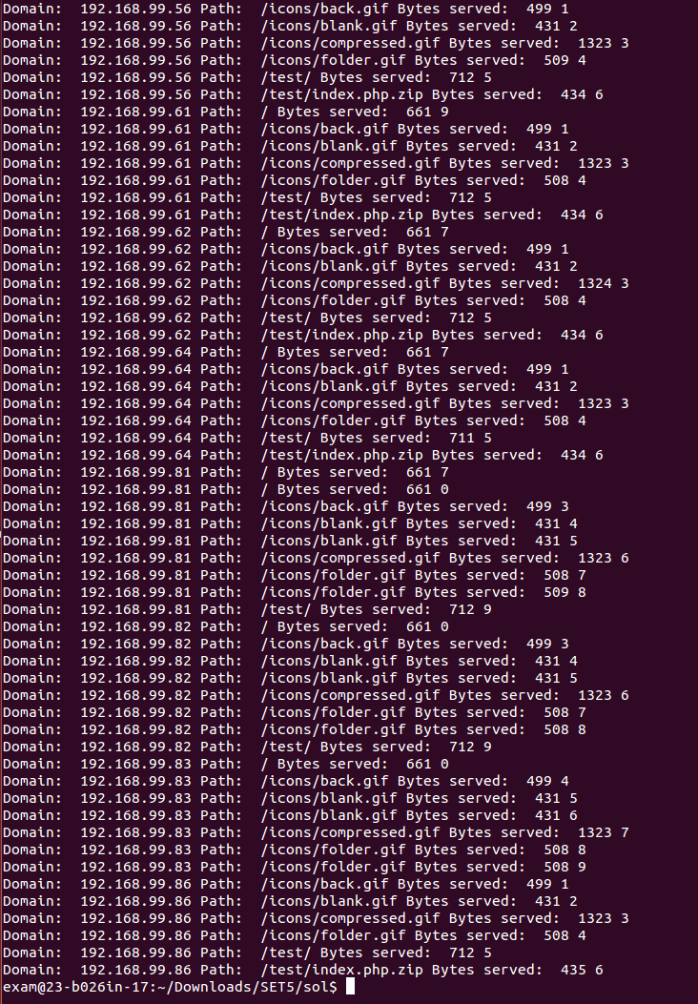
- On accesslog.txt
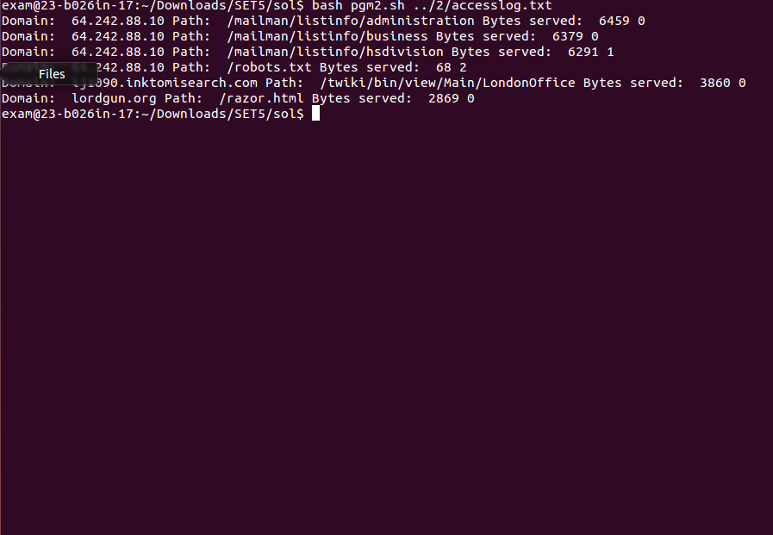

Question 3
Implement calculator to convert distances between (both ways) miles and
kilometres. One mile is about 1.609 kilometres. User interface
(distance.html) has one text-input, two radio-buttons, submit and reset
buttons. Values are posted to a PHP-script (distance.php) which calculates
the conversions according the user input.

Solution:
An HTML page is created, it has a form with two input fields, one for entering a value in kilometer and another for entering a value in miles.
It also has a submit button which calls the php script and another reset button that clears the values in the textbox.
Another php file is written where the conversion happens. The php file checks whether the Submit button is pressed it also checks which text field is empty in order the toggle the correct conversion. The converted value is then echoed onto the web-browser.
If the reset button is pressed then the page reloads.

